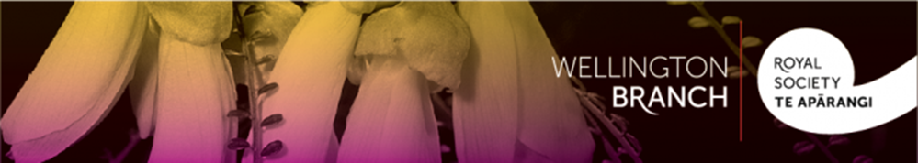

Royal Society Te Apārangi Wellington Branch and
the Royal Society Te Apārangi
Joint Public Lecture

On Wednesday 7 June at 6.00 pm the Royal Society Te Apārangi Wellington Branch and the Royal Society Te Apārangi will host a free public lecture. We hope that you will attend and contribute to the discussion afterward. Please come along. Full details of the lecture are given below.

Wednesday 7 June 2023
6.00 - 7.00 pm at the Royal Society Te Apārangi premises,
11 Turnbull St. Thorndon, Wellington

Dr. Burton King, General Surgeon and Head of The Breast Centre at Bowen Hospital

A History of the Breast in Art and Disease
Dr. King will discuss evidence of breast disease, seen incidentally in visual art, especially in renaissance paintings. We look forward to seeing you there.

David Lillis
Royal Society of New Zealand Wellington Branch

